Prompt 1: "Help me with this"
Upload: Program3-Spr25 CS441.pdf, expression-evaluator CS441.rkt
LLM Response: Parsed the assignment PDF, summarized each required feature, confirmed file contents, and offered to inspect the uploaded Racket file or provide a complete solution.
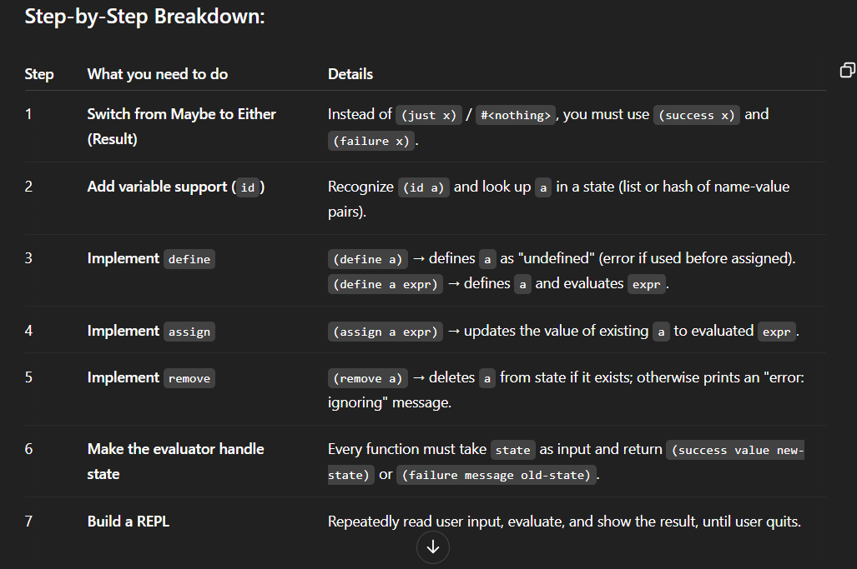
Prompt 2: "Can you give me a code that answers all the prompts for program 3"
LLM Response: Built a complete .rkt file meeting all requirements:
- Replaced Maybe with Either using success and failure
- Implemented functional environment state
- Added support for (define id), (define id expr), (assign id expr), (remove id)
- Handled errors cleanly with appropriate messages
- Created a REPL interface
